School Voting System (voting-app3)

Administrator Manual

Version 1.0 — November 3, 2026
Prepared from the codebase and the interactive guide (guide/)

Table of Contents
Right-click here and choose “Update Field” to build the table of contents.

1. About this manual
This manual is for election administrators: the people who create elections, manage student records, monitor live results, produce winner reports, and maintain the system. It covers every panel of the admin dashboard in the order you will typically use them.

2. Signing in
Go to the admin login page and enter your admin username and password. Like the student side, failed attempts are rate-limited (8 per 5 minutes per network), and a wrong password gives the same message as a wrong username — this prevents attackers from discovering valid usernames.
When you are done, use Log Out — especially on shared computers.

3. The admin dashboard
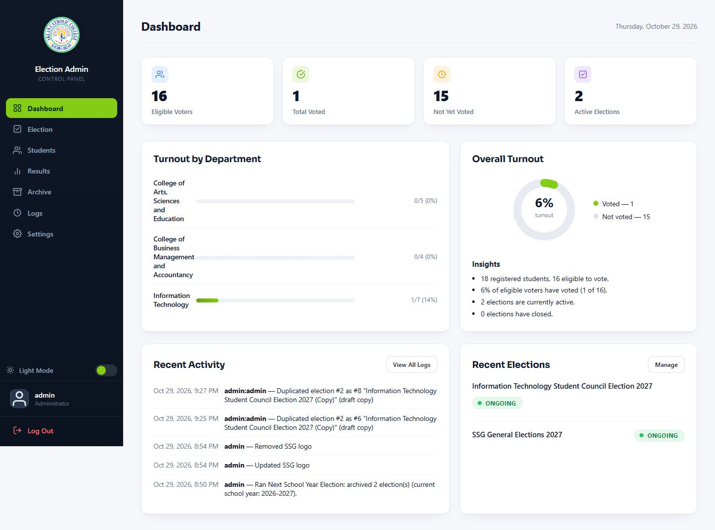
Admin dashboard
The sidebar gives access to seven panels:
Panel | What it manages
--- | ---
Dashboard | Overview counts and quick links
Elections | Election records, the creation wizard, lifecycle actions
Students | Student roster and records
Results | Live and final results, exports
Reports | Winner reports by serving year (print/PDF, XLSX, DOC)
Archive | Past elections (view/restore)
Logs | Activity audit trail and throttling management
Settings | System settings: logo, faculties, year levels, admin accounts, maintenance

4. Elections and the creation wizard
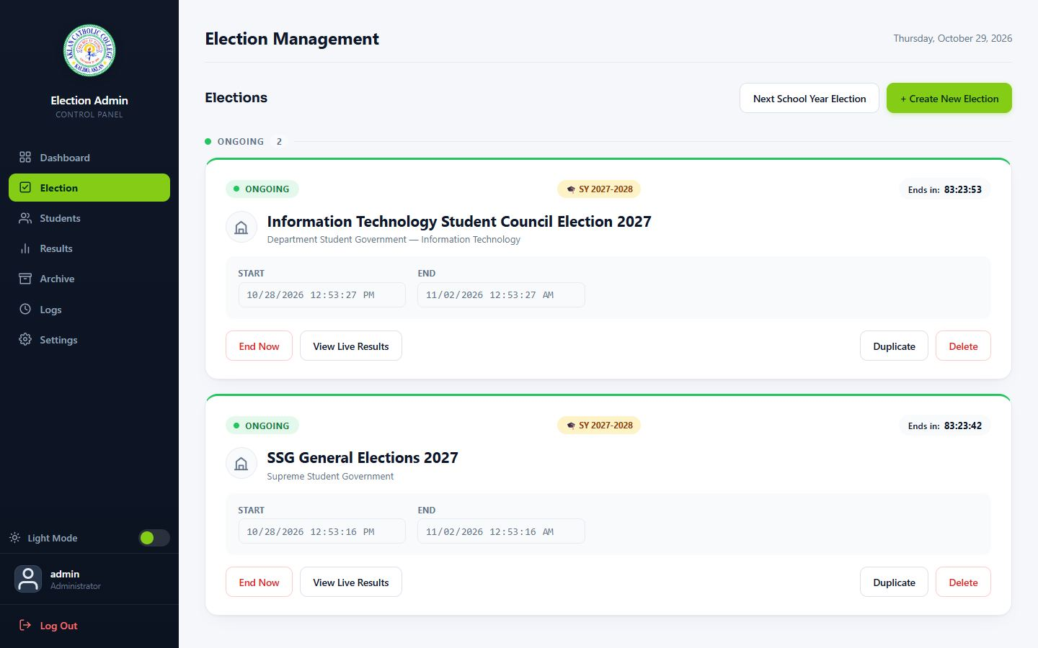
Election panel

4.1 Creating an election (wizard)
1. Step 1 — Details. Name, election type (SSG or DSG), target school year, department (for DSG), description, and schedule (start and end date/time).
- The one-per-year rule is enforced here: only one SSG election may target a school year, and only one DSG election per faculty per school year (archived elections still count).
2. Step 2 — Positions and candidates. Add each position with its settings:
- Display order — drag to reorder; this is the order on the ballot.
- Winner count — how many candidates may be selected. 1 renders a single-choice radio list; higher values render a multi-select list with a cap.
- Year restriction — optionally limit the position to specific year levels (e.g. 4th-Year Representative).
- Add candidates per position: name, party, department/course, year level, platform text, and photo (JPEG/PNG/GIF/WebP, 1–5000 px, up to 2 MB; anything else — including SVG — is rejected).
3. Save. New elections start as Draft and are invisible to students and the public.

4.2 Election lifecycle
Draft → Scheduled → Ongoing ⇄ Paused → Closed → Archived
Action | Effect | Notes
--- | --- | ---
Schedule | Sets the start/end times | Status flips to Ongoing automatically when the start time passes (checked lazily on each request — no cron needed)
Pause | Voting temporarily disabled | Students see "Paused"; resume anytime
Resume | Voting reopens | —
Close | Voting ends permanently | Results become final for that election
Archive | Moves the election to the Archive panel | Excluded from dashboards and lists
Restore (from Archive) | Returns the election to its prior state | —
Delete | Only drafts can be deleted | Elections with votes cannot be deleted — data preservation

Previewing the ballot: from an ongoing/scheduled election, open the student-ballot preview. You can see exactly what students will see, but all submit buttons are disabled — administrators cannot submit ballots, not even accidentally, and hand-crafted requests are rejected by the server.

5. Students
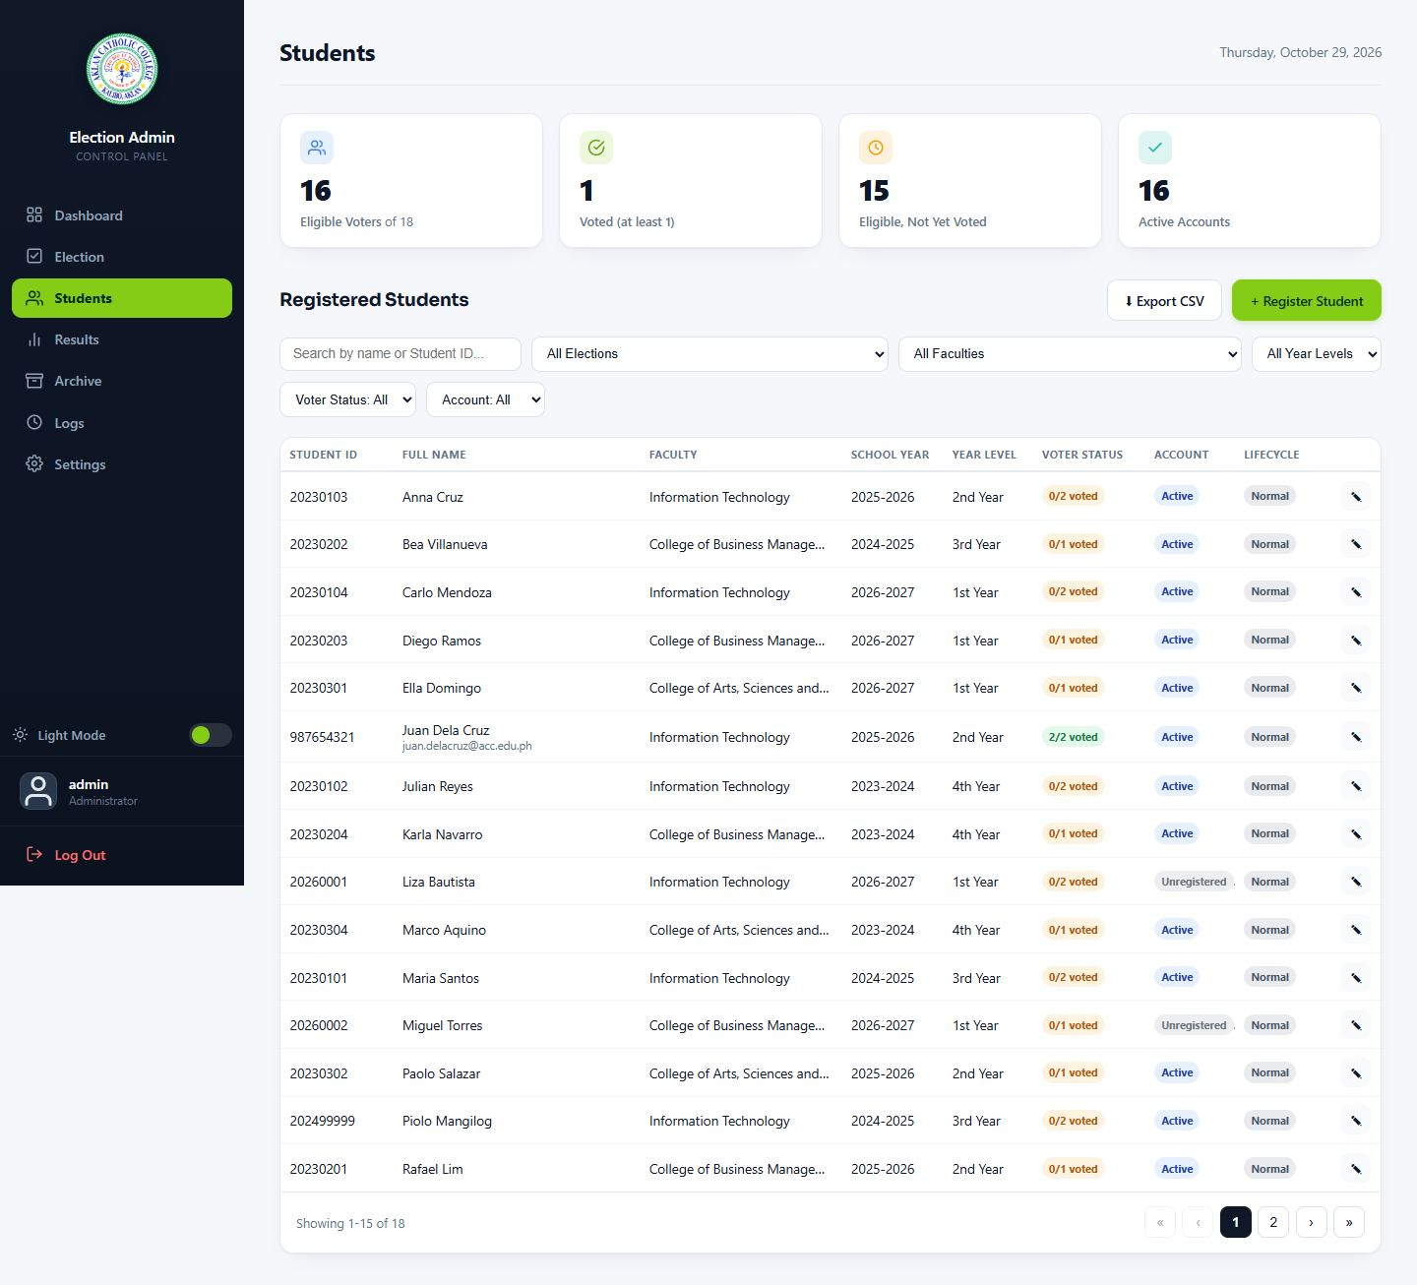
Students panel
Action | How | Notes
--- | --- | ---
Find students | Search box + filters (department, year level, status) | —
Register a student | New Student form | Same 9-digit ID rules as self-registration; the year level derives from the ID
Edit a student | Row → Edit | Correct names, department, course; the year level normally derives itself
Suspend / unsuspend | Row action | Suspended students cannot log in; their data is retained
Reset password | Row action | Generates a temporary password shown once — copy it and hand it over securely; the student is prompted to change it on next login
Export CSV | Toolbar | Opens in Excel; name fields are guarded against spreadsheet formula injection
Delete | Restricted | Students with vote history cannot be deleted

6. Results
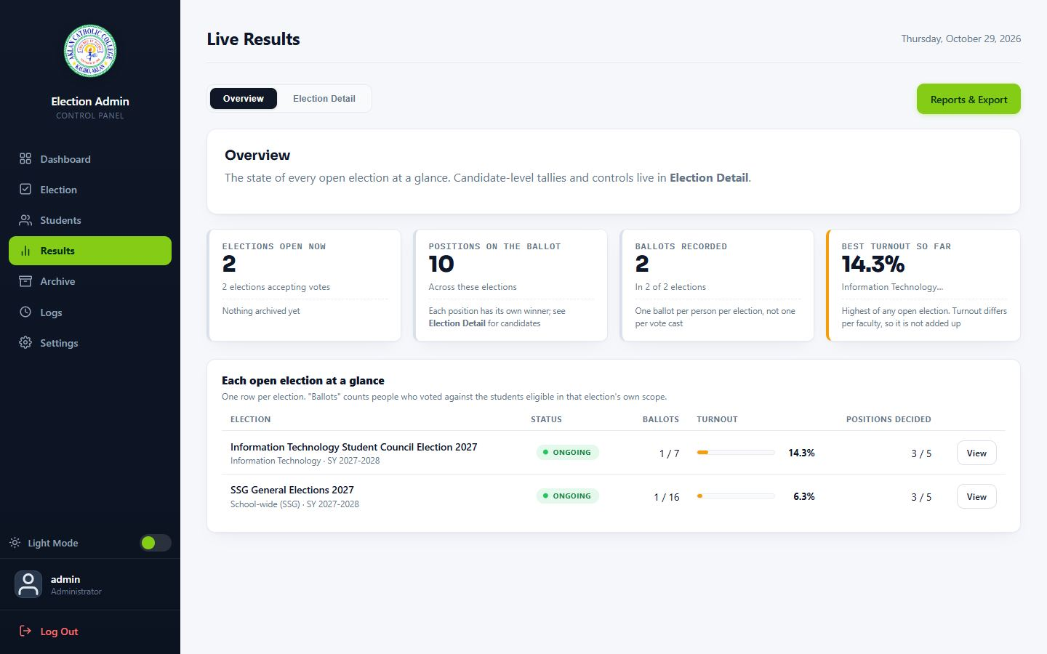
Results panel
- Overview tab: all elections with ballots cast, turnout (distinct submissions — an all-skipped ballot still counts as participation), and status.
- Detail tab: per-position breakdown — every candidate, count, percentage, and bar; Leading badge; exact ties all badge as Leading (never auto-broken).
- Visibility pills: per election, set who may see results — Always, After close, or Never. The rule is enforced server-side; students cannot bypass it by guessing URLs.
- Exports: spreadsheet export of the current view.

7. Reports
The Reports panel produces winner reports for a serving school year:
1. Pick the serving school year; choose SSG or DSG.
2. For DSG, select the faculty sections to include and reorder them as needed.
3. Choose an output: Print / PDF (browser print dialog), XLSX spreadsheet, or DOC document.
4. Tied results are explicitly listed as ties in the report.
Use Reports after each election closes to produce the official record for the serving year.

8. Archive
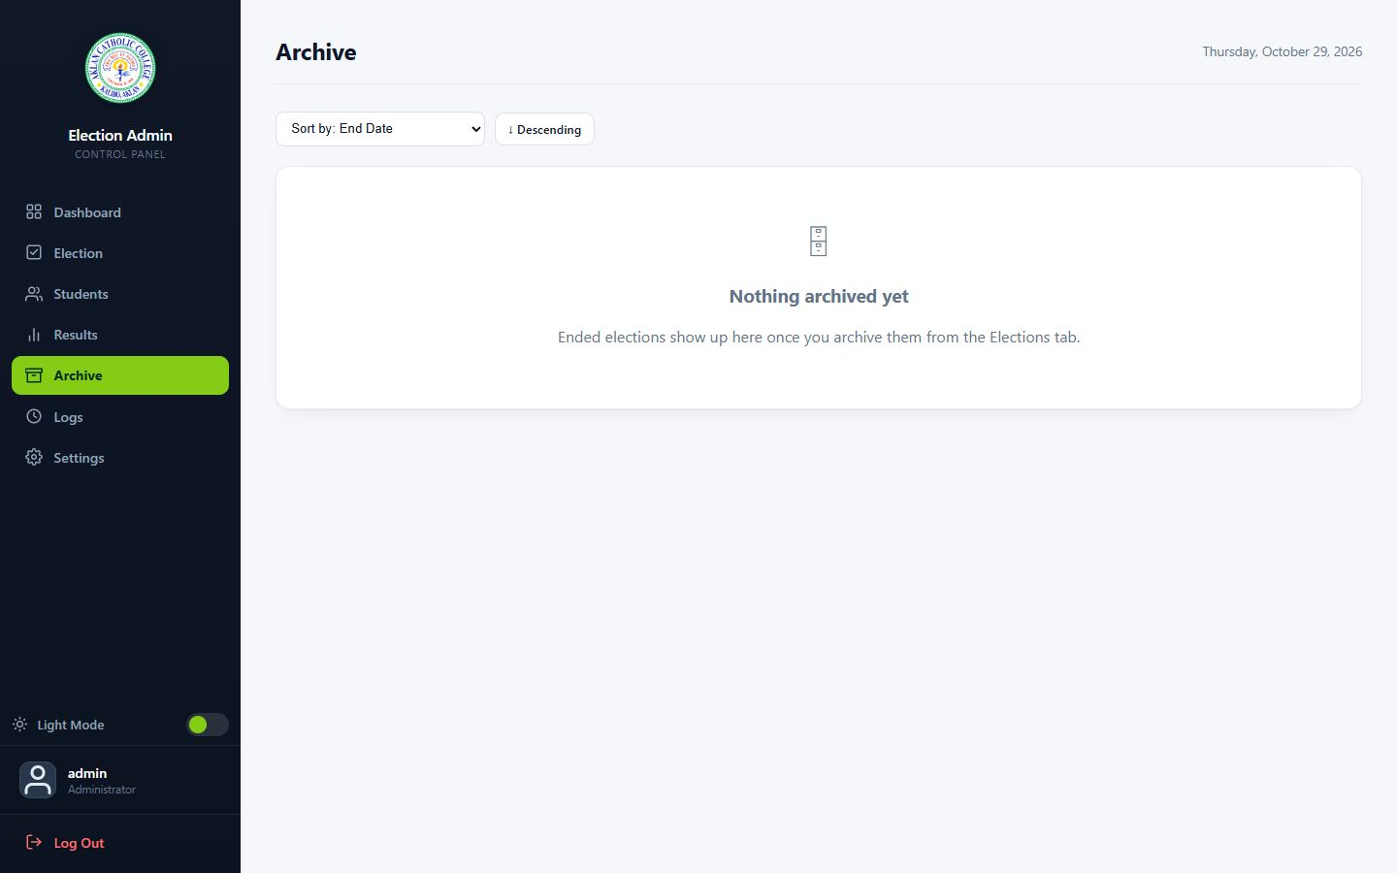
Archive panel
Archived elections keep their full record — candidates, positions, vote counts — for future reference and report generation. Restore an election if it was archived by mistake. Archived elections do not appear on student dashboards or the public site, and they still occupy their "one SSG per school year" slot (this prevents a re-run election from being created for the same year).

9. Logs and settings
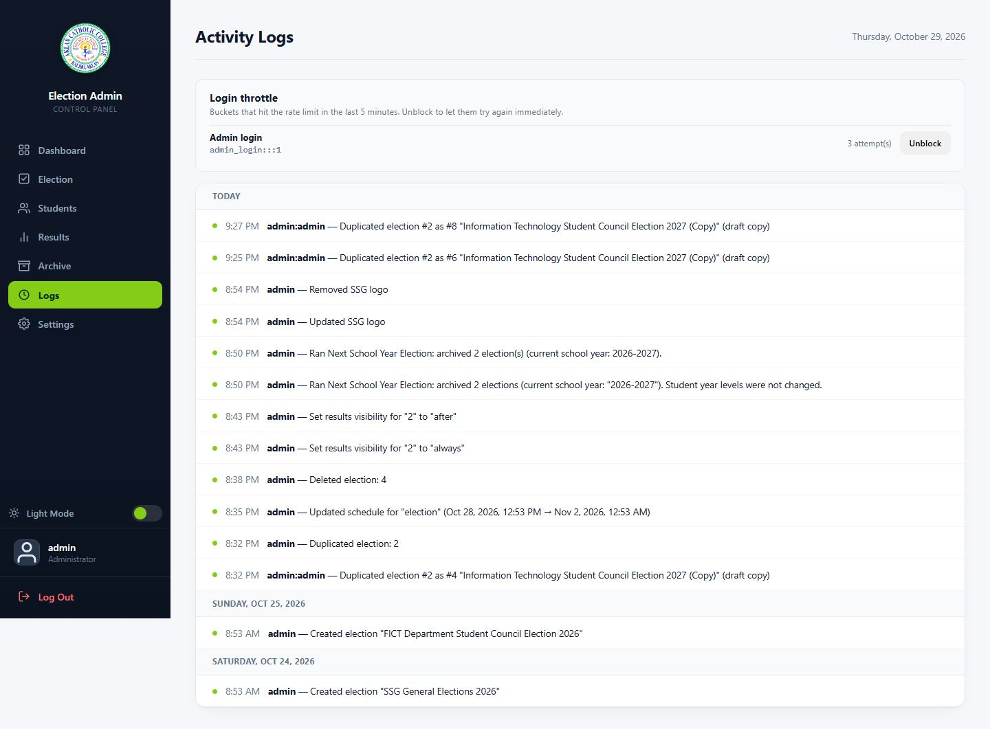
Logs panel

9.1 Activity logs
Every admin write (create/update/delete elections, students, settings) is recorded with the acting admin, timestamp, and what changed. Use this for audits and to investigate unexpected changes. The same panel manages throttling: if a legitimate user or network was blocked by rate limiting, you can inspect and clear the entries here.

9.2 Settings
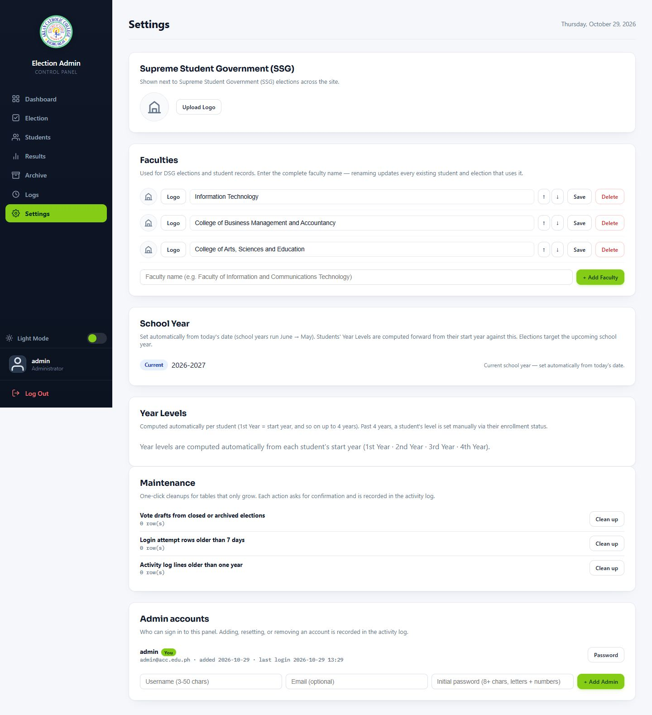
Settings panel
Setting | What it does
--- | ---
SSG logo | Upload the logo shown on student ballots (same image rules as candidate photos)
Faculties | Rename faculties — the change cascades to DSG elections and candidates that reference them
Year levels | Reorder year levels; order follows the list shown to students
Maintenance | One-click cleanup: prune old vote drafts, expired login attempts, and stale log entries
Admin accounts | Add or update administrator accounts (usernames and passwords)

10. Next School Year (rollover)
At the June 1 cutover, run Next School Year from Settings:
1. The new school year row is created and becomes the single active school year (the system enforces exactly one active year at the database level).
2. Students' year levels advance automatically (derived from their ID's start year).
3. Students beyond the four-year window who have not declared a status are flagged and asked to declare on next login (needs_account_update).
4. Graduated students (past the window with a graduated declaration) are marked accordingly.
5. Verify afterwards: dashboard greeting shows the new SY; election targeting defaults to the new year; old elections remain intact under their own target years.

11. Year-end election playbook (recommended)
1. Weeks before: create the election (wizard), enter positions and candidates, collect photos early; dry-run the ballot via Preview.
2. Day before: take a manual database backup (Document 08 §6.2); set results visibility as decided; brief the tabulators on the Results panel.
3. Election day: monitor turnout on the Dashboard; use Pause only for verified incidents (it is logged); keep an eye on Logs.
4. After close: results finalize; generate the Reports (print + XLSX + DOC); take a post-election backup; archive the election.
5. June 1: run Next School Year (§10).

12. Frequently asked questions
Can I see how an individual student voted?
No. The system records participation (that a student submitted a ballot) but ballot content is anonymous by design. Nobody — including administrators — can retrieve individual selections.
I paused an election by mistake. What now?
Resume it. The pause/resume action is recorded in the activity log.
Why can't I delete an election that has votes?
Data preservation: results and reports depend on the full record. Archive it instead — archives are reversible.
A student says they "already voted" but see no Vote button.
That is the expected behavior — the button disappears once a ballot is submitted. Check Results → participation to confirm they are counted.
Two candidates show "Leading" — who won?
They are tied. The system reports ties and does not break them; the tie-breaking procedure is external (college rules), and the report lists the tie explicitly.
I renamed a faculty and now the DSG election shows the new name — is that right?
Yes. Faculty names cascade to everything referencing them.
A student is locked out after failed logins.
Wait for the rate-limit window to pass, or clear the entries in Logs → throttling (§9.1).
When does "Scheduled" become "Ongoing"?
Automatically, when the start time passes — the next request to the system (by anyone) triggers the status sync. There is no button to press and no cron job required.

